

Medical Store Project

- Member #1 : Ibraheem Mohammed Abd ElTwab
- Id #1 :2301915
- Member #2 : Amr Fathy Abd elkader Hussein
- Id #2 : 2301933
- Member #3 : Mahmoud medhat mohamed
- Id #3 : 2301199

Case Study
- Medical Store decides to store data of orders, Supplier, Products, and Customers in the database, The company has wisely chosen
to hire you as a database designer.
- These are the required business rules:
- 1. Each Customer has a customer ID, Name, Address, Contact, and Type may be (Individual, Hospital, or Pharmacy ).
- 2. Each Order has the Total Amount, order ID, order date, Delivery, and state of order is Delivered or Pending.
- 3. Each product has a price, Expiry Date, Amount, product, and Name.
- 4. Each suppliers have a Suppler_ID , Name , Address , Contact Number , Product_Category .
- 5. Each Customer may have an order but Each order Must have a Customer.
- 6. Each Supplier may supply products but Each Products Must have a Supplier.
- 7. Each Order Must Check Products but Each product may be checked by order.
- 8. Each Customer can order many Orders but has one Customer.
- 9. Each Order can Check many Products, and Products can be found in many Orders.
- 10. Each Supplier can Supply Many Products, But Products Have one supplier.

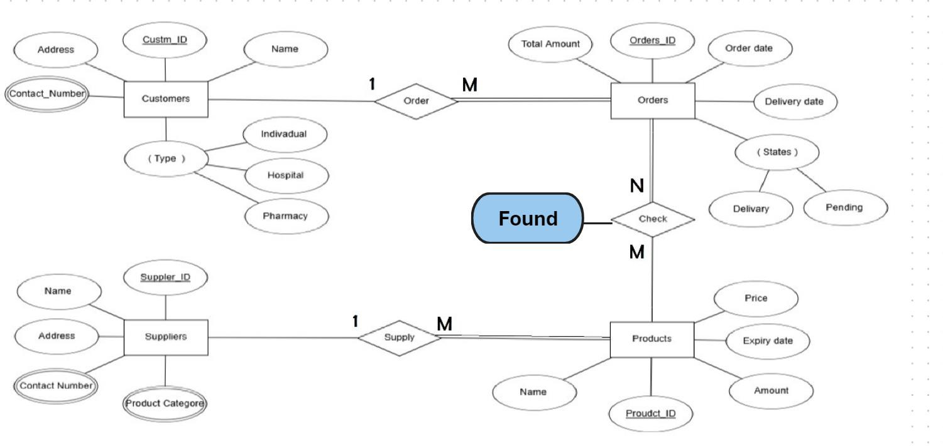ERD

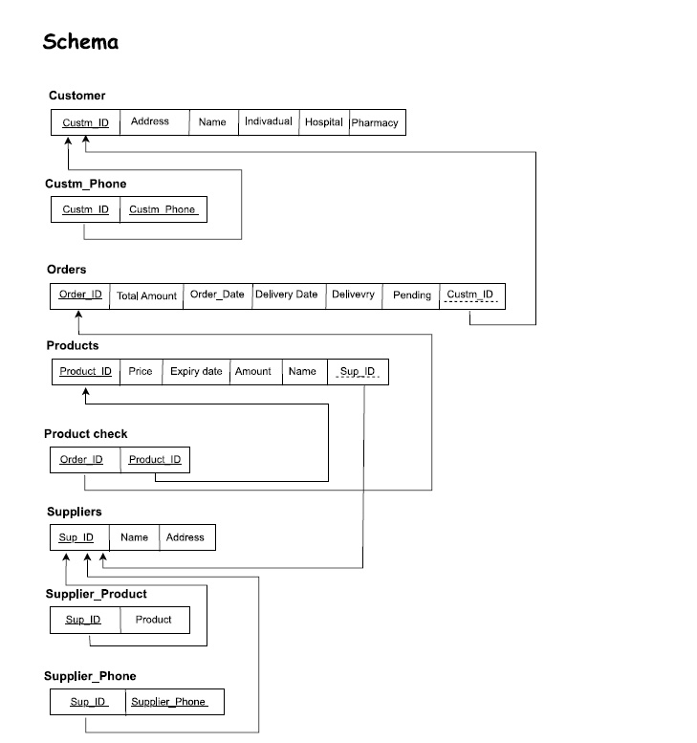

Found

